Signal Processing and Analysis for ECG Data Arising from Rehab Patients Doing Exercises

Authors Name/s per 1st Affiliation (Author)
line 1 (of Affiliation): dept. name of organization
line 2-name of organization, acronyms acceptable
line 3-City, Country
line 4-e-mail address if desired
Authors Name/s per 2nd Affiliation (Author)
line 1 (of Affiliation): dept. name of organization
line 2-name of organization, acronyms acceptable
line 3-City, Country
line 4-e-mail address if desired

Abstract — Cardiac disease is serious threat to human health and has become the leading cause of death worldwide. Thanks to improvements in medical treatment and health care, more and more people are able to survive after intrusion of cardiac disease but with complex health conditions. Therefore rehabilitation for patients with cardiac disease is important for these patients to live a life with quality. This paper studies the conditions of patients with cardiac disease during rehabilitation exercises by monitoring their ECG signals. Specifically, their ECG signals from different rehabilitation exercises are analyzed. The findings from this study will be helpful to practice more efficient rehabilitation activity.
Keywords—rehabilitation monitoring, ECG, wearable device, heart disease

Introduction
Cardiac disease is one of the major chronic diseases among the aging population and is the leading cause of death globally. Many patients who survived from the intrusion of cardiac disease face the problem of functional capacity loss. Cardiac rehabilitation in particular rehab exercise is widely recognized not only to enhance cardiopulmonary functions thus improve the quality of life but also to reduce mortality and morbidity rates [1]. Therefore cardiac patients are encouraged to attend cardiac rehabilitation program.
Although many studies have demonstrated that the risk of major cardiovascular events during supervised rehabilitation exercise is very low [2-3], there are still a lot of patients who are hesitating to meet the exercise intensity assigned by their doctors. ECG monitoring is able to provide the information about the conditions of cardiac system therefore useful to improve the efficiency of the rehabilitation activity.
In this paper ECG signals collected from real patients using a wearable device are processed and analyzed. Since patients undergoing cardiac rehabilitation conduct different types of exercises, their ECG signals are analyzed based on exercise type to provide information of the cardiac conditions of patients. The analyzed results obtained from ECG monitoring are also compared with the measured data recorded by intermittent type monitor. We hope the information for specific types of exercises will help to manage the rehabilitation activity better.

METHODS AND MATERIALS
ECG data collection has been conducted in the Rehabilitation Lab of a local hospital from clinical subjects who were undergoing cardiac rehabilitation. Institutional review board (IRB) approval was obtained for this data collection and informed consent signed by patients was obtained.
This project is a joint work partially supported by Delta Electronics Inc., Taiwan.

Practice of Rehabilitation Activity in Local Hospital
Rehabilitation activity has been performed in local hospital for many years. The practice of a rehabilitation session consists of warming up, three types of exercises and cooling down. Each exercise lasts for fifteen minutes and between any two exercises the patient is allowed to rest for two minutes. There are four types of exercises, i.e. treadmill walking, static cycling, arm cycling and indoor rowing. Each patient conducts three out of the four types of exercises in the rehabilitation activity. The exercise of treadmill walking and the exercise of static cycling are compulsory while the third exercise, arm cycling or indoor rowing, will be assigned by the physiotherapist according to the health condition of the patient respectively.
The rehabilitation activity is performed once a week (one session) for a patient and one phase of rehabilitation activity will last for three months. Before the commencement of rehabilitation activity, a doctor will assign a targeted heart rate for specific patient according to his own conditions. Suitable speed of the treadmill and proper friction of the equipment for static cycling, arm cycling and indoor rowing will be tested and settled for every patient in the trial session.
In each rehabilitation session, heart rate and blood pressure are measured and recorded for each patient before the warming up and after the cooling down. The heart rate is also measured and recorded during each type of exercise once for every patient.

Data collection and database unsed for this study
To monitor patients’ cardio conditions during rehabilitation exercises, a wearable device with non-contact ECG sensors has been developed to capture the ECG signals and record the ECG data. The wearable device can be put on easily on top of a cloth which the patient is wearing. It’s convenient and comfortable to use as no skin-contact is required.
Real patient data have been collected in the rehabilitation lab of a local hospital using the device described in Section II-B. The rehabilitation activity is conducted as normal and the patient does the same as before except he needs to put on the wearable device and his ECG signal is recorded during the whole rehabilitation session.
Before the warming up and after the cooling down, the heart rate and blood pressure are measured for the patient using non-invasive blood pressure monitor (Dinamap Procare 300 from GE). During each type of exercise, the heart rate of the patient is measured once using portable SpO₂ patient monitor (Nellcor PM10N from Covidien), where the sensor is clipped at one of the fingers so that the patient can continue the exercise without interruption.
As different types of exercises were carried out continuously, to void the effect of the sequence of different exercises, the order of the three exercises for each patient was randomly arranged.
ECG data have been successfully collected from twelve volunteer patients who were undergoing rehabilitation activity after the treatment or operation due to their heart diseases. All volunteers are male patients with heart diseases range from Angina, Acute Myocardial Infarction (AMI) to Ischaemic Heart Disease (IHD). The age of the patients ranges 62.7±8.4, the weight ranges 71.4±16.1 kg and the height ranges 1.68±0.06 meter.
In this study, both the measured parameters and the parameters calculated from the ECG signals recorded in the data collection using the above-mentioned device are used. The ECG signal obtained from each patient is partitioned into three portions according to the type of exercises. The signal processing, feature extraction and data analysis is conducted on these portions respectively. In order not to affect the result, the frames of ECG signals with big noise and interference are excluded in this study.

Signal processing and data Analysis
Signal processing, feature extraction and data analysis of the ECG signal have been performed off-line using MATLAB software at the server-end. The goal of signal processing of the ECG signal is to detect the R-peak accurately. Based on these detected R-peaks, the RR intervals or the IBI (inter-beat interval) can be calculated precisely. An IBI represents time duration between two consecutive R-peaks of ECG signal. Variation of IBI embedded in a series of IBI contains the information of heart rate variability (HRV) as IBI is reciprocal to the heart rate.
HRV can be analyzed in many ways. Commonly used HRV analysis includes time domain analysis, spectral analysis and nonlinear analysis [4]. The time domain features invoked in this study include: the mean value of normal-to-normal (NN) IBI (meanIBI), the standard deviation of NN IBI (SDNN), the standard deviation of meanIBI of segments (SDANN), the mean value of heart rate (meanHR), the standard deviation of heart rate (SDHR), the root mean square successive NN IBI difference (RMSSD), and the percentage of successive NN IBI that differ by more than 50ms (pNN50). In spectral analysis, wavelet transform (WT) method is used to compute the power spectral density of the high frequency band (HF, 0.15-0.4 Hz) and the low frequency band (LF, 0.04-0.15 Hz). The spectral features include: amount of low frequency (pLF), amount of high frequency (pHF), normalized percentage of low frequency (nLF), normalized percentage of high frequency (nHF), ratio of low frequency to high frequency (rLFHF). HRV triangular index (HRVTi) and triangular interpolation of NN interval histogram (TINN) are used as non-linear geometric features. Poincare analysis is also used in the nonlinear HRV analysis.

preliminary RESULTS AND DISCUSSION

Measured parameters
The heart rate and blood pressure measured before the warming up, during each type of exercise and after the cooling down for all patients are recorded as in Table I. The targeted heart rate assigned by the doctor is also presented.
Comparing the parameters measured before the warming up and after the cooling down, it can be seen that the blood pressure decreases and the heart rate increases after the rehab exercises for all patients. For the one-off measured heart rate for every type of exercise of each patient, most of the values are either within the range or around the assigned targeted heart rate. The measured values that are either more or less than 10% of the assigned targeted heart rate are displayed in red. It is clear there’s only one patient whose measured heart rate is higher than the assigned targeted heart rate during all three types of rehab exercises.
The above observations imply that the goal of the rehabilitation activity is roughly achieved.
Table I Measured parameters for all patients
No | Targeted HR | Pre | Tread-mill | Static cycling | Arm cycling | Indoor rowing | Pro
1 | 90~100 | 114/64, 71 | 94 | 96 | N.A. | 103 | 107/65, 76
2 | 100~105 | 120/59, 60 | 94 | 98 | 104 | N.A. | 108/50
3 | 85~90 | 117/61, 62 | 84 | 89 | 82 | N.A. | 103/58, 74
4 | 100~110 | 131/81, 68 | 105 | 111 | 95 | N.A. | 104/68, 87
5 | 90~95 | 153/75, 56 | 72 | 82 | 83 | N.A. | 113/60, 60
6 | 95~100 | 133/86, 65 | 117 | 105 | 86 | N.A. | 123/73, 73
7 | 102~110 | 148/66, 72 | 90 | 103 | N.A. | 113 | 123/67, 76
8 | 80~85 | 102/65, 77 | 107 | 105 | 95 | N.A. | 103/58, 79
9 | 70~80 | 126/60, 56 | 77 | 74 | 66 | N.A. | 122/68, 58
10 | 85~90 | 137/70, 66 | 100 | 87 | 85 | N.A. | 135/65, 70
11 | 110 | 149/65, 61 | N.A. | 105 | 94 | N.A. | 138/64, 94
12 | 100 | 152/89, 70 | 105 | 92 | 87 | N.A. | 138/60, 78

Case Study
In this case study, we use patient No. 1 as an example to illustrate the parameters calculated from the ECG signal collected during his rehabilitation session.
Fig.1. displays the NN IBI of patient No.1 derived from ECG signal for the exercise of treadmill walking (TW). It can be seen that the distribution of the NN IBI is quite concentrated, steadily within the range of 0.61 to 0.68.
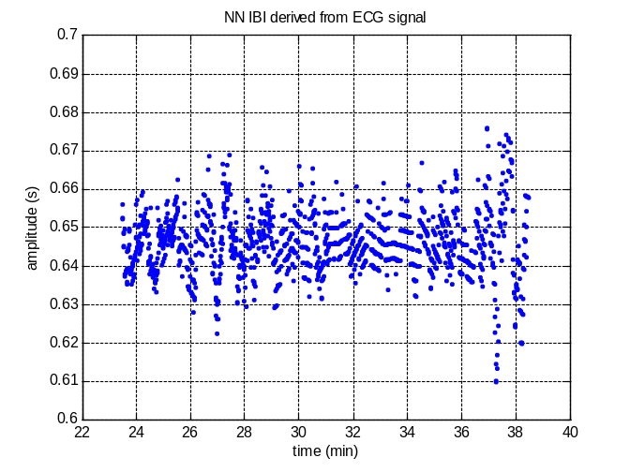
Fig.1. NN IBI of patient No.1 derived from ECG signal for treadmill walking
Since IBI is the reciprocal of the heart rate, after IBI is obtained, the heart rate can be derived directly from the IBI. Fig.2. presents the heart rate of patient No.1 derived from IBI for the whole rehab session. To smooth the curve of heart rate thus make it conform to people's observation habits, we calculate the heart rate using the mean value of NN IBI for every one minute instead of using the instantaneous NN IBI value.
It can be seen clearly from this figure the different phases of the rehab session. There are three stages that the heart rate of the patient is high, which correspond to exercises of static cycling, treadmill walk and indoor rowing in sequence. While the phases between these stages with high heart rate are with relatively low heart rate. It’s obvious that the stages with high heart rate correspond to the phases while the patient was doing the exercises and the phases with relatively low heart rate are the resting duration between exercises. The starting portion and ending portion of the curve correspond to the phases before the warming up and after the cooling down, and are with low heart rate. Small peaks with relatively high heart rate are also observed just after the starting portion and before the ending portion. They correspond to the warming up phase and the cooling down phase respectively.
Curves of heart rate for other patients have also been plotted but not shown here due to the space limit. All these curves have similar property, i.e. high heart rate during the exercise phases, relatively low heart rate during resting phase between exercises, relatively high heart rate during the warming up phase and the cooling down phase, and low heart rate during the starting portion and ending portion of the curve.
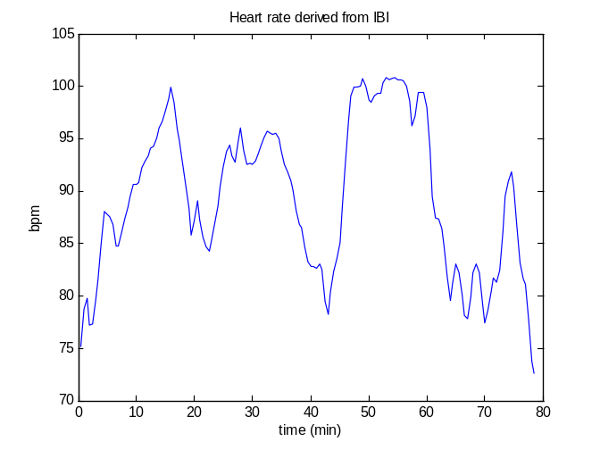
Fig.2. Heart rate of patient No.1 derived from IBI for the whole rehab session
The Poincare plot of patient No.1 for the exercise of static cycling (SC) is shown in Fig.3. Poincare plot, which is also known as the first-return map, is a plot of IBI intervals versus the previous IBI interval. Poincare plot is a nonlinear analysis to measure the self-similarity. SD2 is the standard deviations (SD) along the line of identity and represents the SD of the continuous or long-term variability. SD1 is the standard deviations perpendicular to the line of identity and represents the SD of the instantaneous beat-to-beat variability or short term variability. In this case, the value of SD1 is 5.4ms and the value of SD2 is 38.7ms. The ratio of SD2 to SD1 (r_SD) is 7.17 and the corresponding ellipse, shown in red curve, is quite flat. The area of the ellipse (A_SD) is 656.5ms².
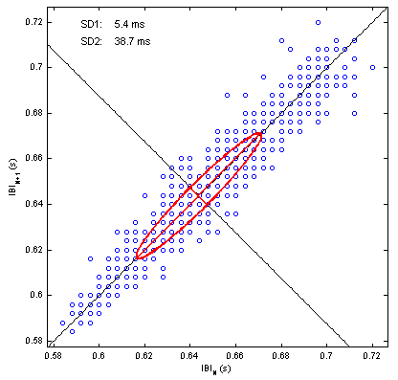
Fig.3. Poincare plot of patient No.1 derived from ECG signal for static cycling

Results on different features for all patients
Different parameters for all patients during each type of exercises have been calculated from their corresponding ECG signals. In all figures within this section, the results for the exercise of treadmill walking, static cycling, arm cycling and indoor rowing are shown in red, blue, black and pink respectively. Results from different patients are represented by different symbols and displayed in order along the index axis.
- Mean value of NN IBI and its standard derivation
Fig.4 presents the results of mean value of NN IBI and its standard derivation for all patients. It can be seen from the figure, that both patients with parameters for the exercise of indoor rowing have lower mean NN IBI during indoor rowing than during other exercises they took. The standard derivation for the mean NN IBI during indoor rowing is also small.
8 out of 10 patients with parameters for the exercise of arm cycling (AC), have larger mean NN IBI during AC than during other exercises. For those two exceptional patients who have lower mean NN IBI during AC, the variation of mean NN IBI is obviously large compared to other cases.
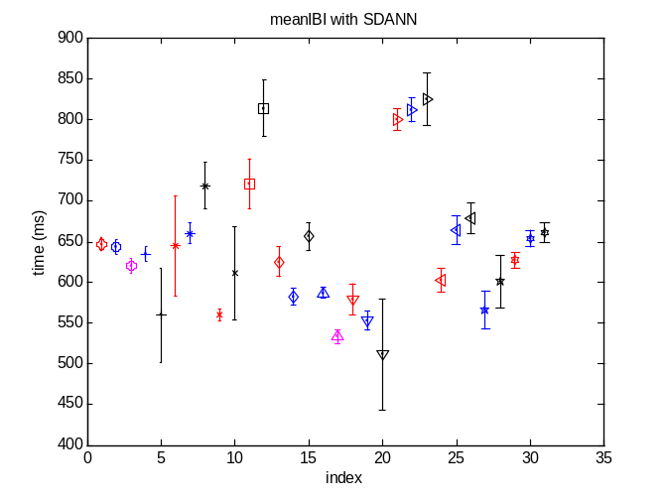
Fig.4. Mean value of NN IBI and its standard derivation
- Mean value of HR and standard derivation of HR
Fig.5 depicted the results of mean value of HR and the standard derivation of HR for all patients. It can be seen from the figure, that both patients with parameters for the exercise of indoor rowing have higher mean HR during indoor rowing than during other exercises they took.
8 out of 10 patients with parameters for the exercise of AC, have lower mean HR during AC than during other exercises. Generally speaking, the standard derivation of HR during AC is large compared to that during other exercises.
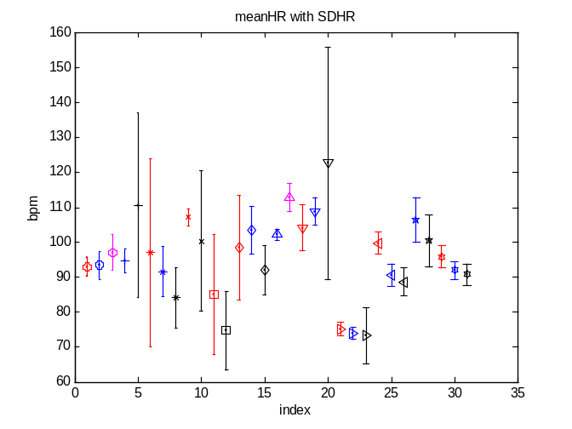
Fig.5. Mean value of heart rate and standard derivation of HR
- Calculated parameters for four types of exercises
Table II shows the average ± std. values of the eighteen features computed for the four types of rehab exercises over the twelve patients. The paired sample t-test is performed on these features between any two out of three types of exercises, i.e. TM vs SC, TM vs AC and SC vs AC. For all the tests, 5% significance level is used. The t-test is not conducted for the exercise of indoor rowing due to unbalanced data size since there are only two data samples for this exercise.
Results of the paired sample t-test are presented in Table II using numbers in parenthesis. 0 indicates that the t-test does not reject the null hypothesis at the 5% significance level. “1” indicates that the t-test rejects the null hypothesis between the current exercise and TM. “2” indicates that the t-test rejects the null hypothesis between the current exercise and SC. “3” indicates that the t-test rejects the null hypothesis between the current exercise and AC.
We can see from these results that between SC and AC, differences are found in 11 out 18 features. AC possesses larger values in SDNN, SDANN, pNNx, RMSSD, sdHR, pLF, pHF, SD1, SD2, A_SD but smaller value of HRVTi compared to SC. As for TM and AC, differences is seen in features nLF and nHF. TM has large percentage of LF components and small percentage of HF components, while AC has decreased percentage of LF components and increased percentage of HF components.
Table II Calculated parameters for four types of exercises
Feature | Treadmill | Static cycling | Arm cycling | Indoor rowing
meanIBI  (ms) | 645.0±74.0  (0) | 635.5±74.4  (0) | 663.5±101.4  (0) | 576.6±61.4
SDNN  (ms) | 43.7±36.7  (0) | 25.7±11.6  (3) | 52.5±19.5  (2) | 28.3±10.8
SDANN  (ms) | 20.1±17.1  (0) | 12.6±4.9  (3) | 35.7±18.9  (2) | 8.8±0.7
pNNx  (%) | 2.9±4.1  (0) | 2.2±4.9  (3) | 8.7±9.3  (2) | 0.050±0.071
RMSSD  (ms) | 30.6±32.1  (0) | 13.9±10.1  (3) | 51.4±28.6  (2) | 7.8±0.7
meanHR  (bpm) | 95.0±9.8  (0) | 95.7±10.2  (0) | 93.7±15.3  (0) | 104.9±11.0
sdHR  (bpm) | 8.8±8.9  (0) | 4.1±2.0  (3) | 12.9±10.2  (2) | 4.7±0.8
pLF | 2455±4192  (0) | 137.6±152.7  (3) | 3233±3367  (2) | 19.4±15.7
pHF | 1089±2094  (0) | 147.9±263.5  (3) | 2126±2089  (2) | 8.2±1.7
nLF | 0.72±0.18  (3) | 0.66±0.16  (0) | 0.59±0.17  (1) | 0.65±0.16
nHF | 0.28±0.18  (3) | 0.34±0.16  (0) | 0.41±0.17  (1) | 0.35±0.16
rLFHF | 6.5±10.2  (0) | 2.6±1.6  (0) | 2.1±2.0  (0) | 2.2±1.5
HRVTi | 5.6±3.2  (0) | 8.0±2.9  (3) | 4.7±1.7  (2) | 5.1±2.2
TINN | 74.9±28.0  (0) | 81.6±52.0  (0) | 115.7±53.4  (0) | 30.4±8.4
SD1  (ms) | 21.7±22.7  (0) | 9.8±7.2  (3) | 36.3±20.3  (2) | 5.5±0.4
SD2  (ms) | 56.5±48.6  (0) | 34.1±17.0  (3) | 63.7±22.6  (2) | 39.6±15.5
r_SD | 4.4±5.8  (0) | 4.9±3.4  (0) | 2.5±2.3  (0) | 7.3±3.4
A_SD  (ms²) | 5574±8943  (0) | 1018±760  (3) | 8203±6497  (2) | 673±215

Discussion
Combining the analysis on both the measured and the calculated parameters, for all patients involved in this study, the rehab activity achieved the effect it supposed to have. The patients had decreased blood pressure after the rehab session. Their heart rate also increased both during the exercises and after the rehab session.
Compared the measured parameters and the calculated parameters obtained from ECG signal, they are highly consistent. However, the ECG monitoring can provide more details of the information on the conditions of cardiac system. According to the heart rate curve derived from the ECG signal, the variation of heart rate during the rehab session is fast and continuous. Therefore a one-off heart rate measurement during exercises is not enough to reflect in time the change of conditions of cardio system of the rehab patients. Continuous monitoring on ECG signal with the technology that can provide real time heart rate can not only encourage the patients to make full effort to meet doctor’s requirement on exercise intensity, but also help the therapists to do a better job in terms of handling the rehabilitation activity in a more efficient way.
General speaking, arm cycling is the exercise with the least intensity while indoor rowing is the exercise with the most intensity. That can explain why there are only two patients (out of twelve patients) assigned to take the exercise of indoor rowing.
Although the friction of the static bicycle and the arm cycler can be pre-set before the rehab session, the speed of turning could vary at the patient’s will. This can be seen clearly in the case study in Section III-B where the heart rate changing always during the exercise of static cycling and never staying at a stable stage. From this point of view, the exercise of treadmill walking is a better choice of rehab exercise. The exercise intensity of treadmill walking can be adjusted by setting different speed of the treadmill, and the heart rate could be retained at stable stage by fixing the speed of the treadmill at a specific value.

CONCLUSION
In this paper, signal processing and analysis have been performed for ECG data collected from rehab patients doing exercises in a local hospital. In order to observe the effects of the rehab activity to these patients, both measured parameters and parameters derived from ECG signals have been used. The ECG signals were analyzed by three different categories of HRV features. The analysis results show that the rehab activity is able to achieve its goal. To strengthen different muscles of the body and increase the fun of rehabilitation activity, different types of rehab exercises can be adopted. Treadmill walking is recommended as a good choice of rehab exercise for its quality control on the exercise intensity and heart rate.
Although the intermittent type monitor is able to provide basic information during the rehab session, continuous ECG monitoring may be necessary to perform the rehab activity with effect and efficiency. It also has the potential to facilitate the home-based cardiac rehabilitation. More investigation will be carried out in the future study on continuous ECG monitoring. Furthermore, more patients with different categories of heart diseases will be recruited to build up a moderate-size database.

Acknowledgmentusles
Special thanks to Dr David Foo and his team at TTSH Rahab Lab.
Ms Yvonne Chow Mei Wan (N.C.)
Ms Doris Tan Bee Leng (N.C.)
Ms Swapna Tony (Principal Physiotherapist)
Ms Jaclyn Chow Jie Ling (Snr Physiotherapist)
Ms Quek Li Qin (Physiotherapist)
Ms Cheryl Heng (Physiotherapist)
Ms Dorcas Soon Teck Lan (Snr. Therapist Asst.)
Ms Stephanie Pinto (Therapist Asst.)
Mr Darius Chua Jie Rui (Therapist Asst.)

References
- O’Connor GT, Buring JE, Yusuf S et al., “An overview of randomized trials of rehabilitation with exercise after myocardial infarction”, Circulation, 1989;80:234–44.
- Steven J. Keteyian, Peggy A. Mellett, Frank J. Fedel, Cathy M. McGowan and Paul D. Stein, “Electrocardiographic Monitoring During Cardiac Rehabilitation”, Chest, 1995;107;1242-1246.
- Bruno Pavy, Marie Christine Iliou, Philippe Meurin, et al. "Safety of Exercise Training for Cardiac Patients", Arch Intern Med. 2006;166(21):2329-2334.
- Heart rate variability: Standards of measurement, physiological interpretation, and clinical use, Task Force of the European Society of Cardiology and the North American Society of Pacing and Electrophysiology, Circulation, 93, pp. 1043-1065, 1996.
- Heart rate variability

